**Name: SALEHA RAFIQUE**

**Sap ID: 49316**

**BSCS-5th Semester**

**OS Lab Tasks**

**Question:** Rename file atomic-notes with at-notes in the books directory.

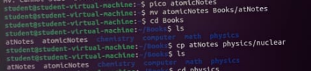

**Question:** Copy this file to sub-directory nuclear under the directory physics.

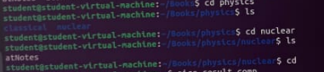

**Question:** Removed Write(w) permission for owner (user) from file result.comp.

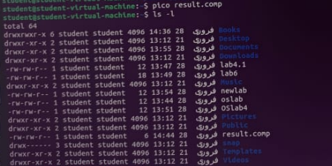

**Question:** Group and other get execute access for file stock.



**Question:** Set group access for reading(r) and execute(x) of myfile.





**Question:** Create a directory called l**ab4** and create three files say quiz, report and viva inside the directory

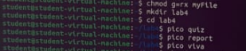

Now try to set the following rights;

**-rw- r-- r- quiz**

-**rw- -w- r- - report**

**-rwx rwx r-x viva**



Also try to change access permission of **lab4** directory as well and see how it affects.

